• What the two CTAs are in your site?



This CTA is meant for micro conversion of visitors of this website to subscribers of the website. On clicking this button, they are led to fill up a sign-up form.

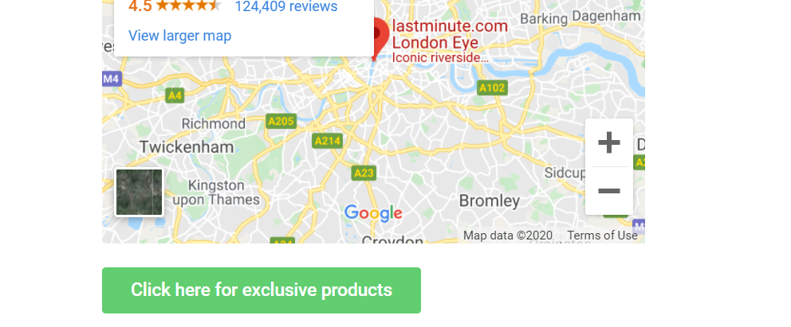

This CTA takes the user to a site where they can see the specs of the products leading to purchase.

• Why these two are indeed CTAs?



This button is a CTA because the visitors are led to receive regular updates. As they sign up using this button, the customers are micro converted. Therefore, this button holds



By clicking on this button, the visitors are taken to products site inducing purchase. Therefore, this button is rightly called CTA

Home Page: <http://spectile.atspace.cc/>

Autologin Page: <http://spectile.atspace.cc/?autologin_code=dVHukfGPwtdnobbWhbcQFuPC1EZkiCc0>